
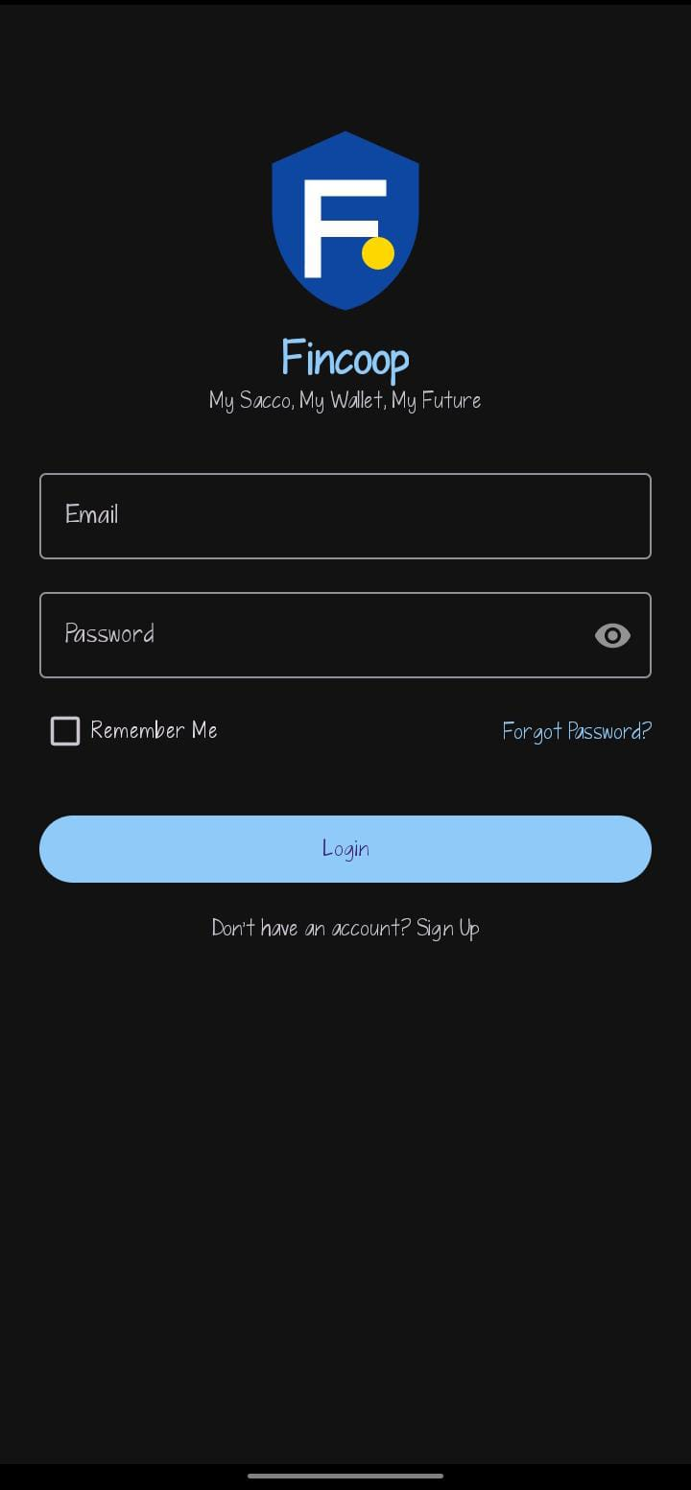
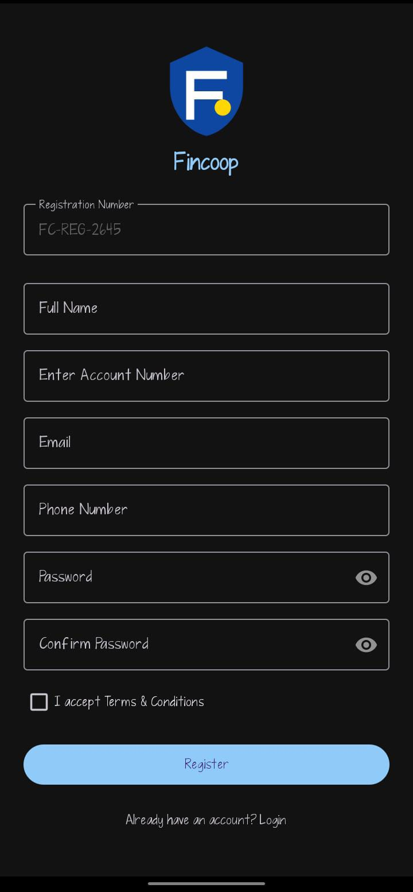

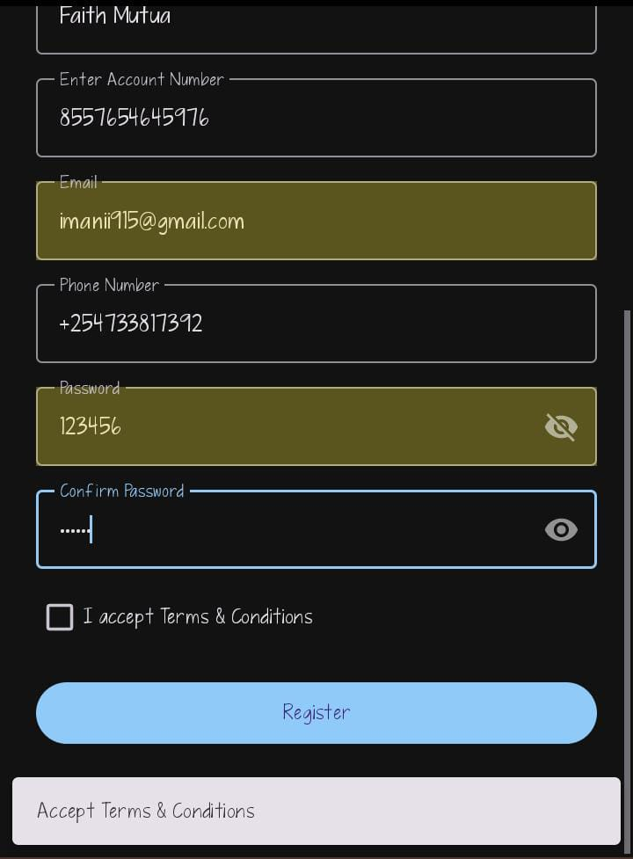
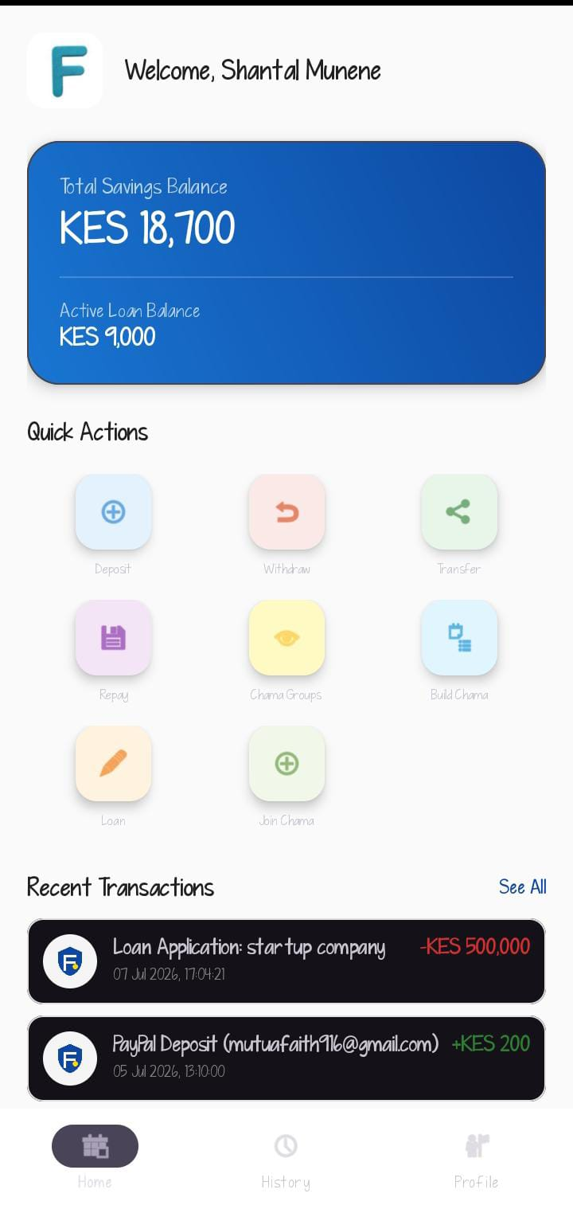
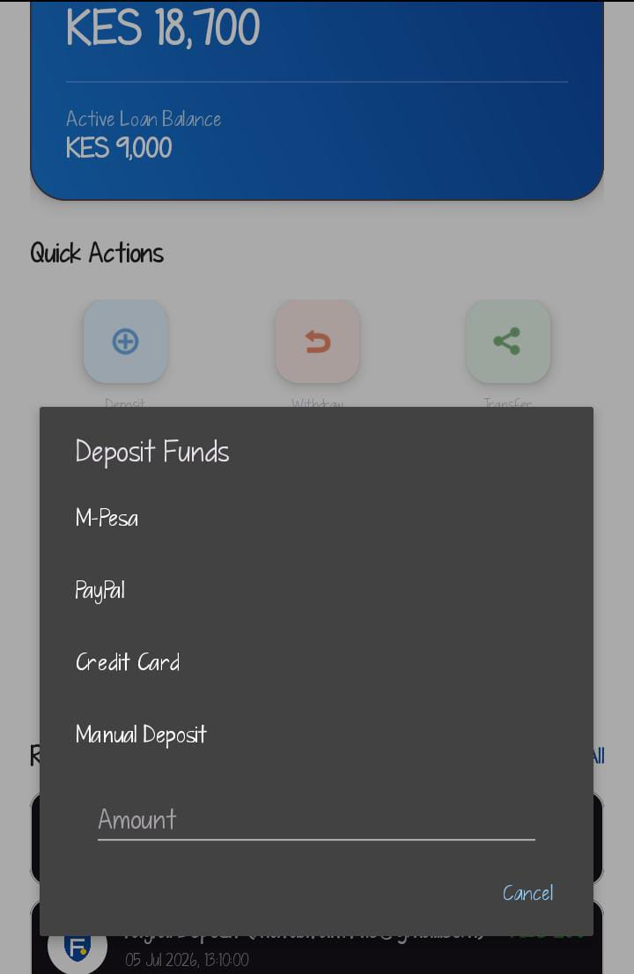
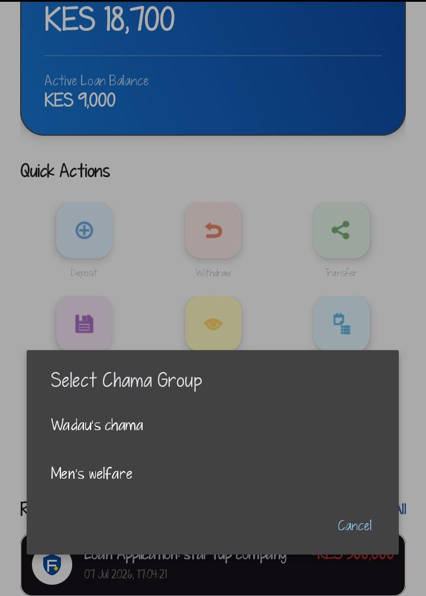
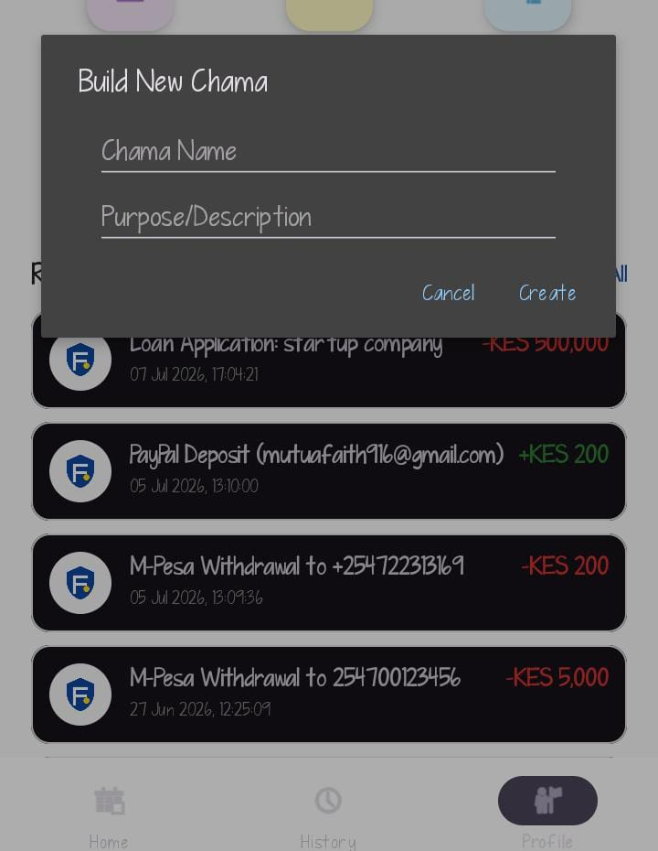

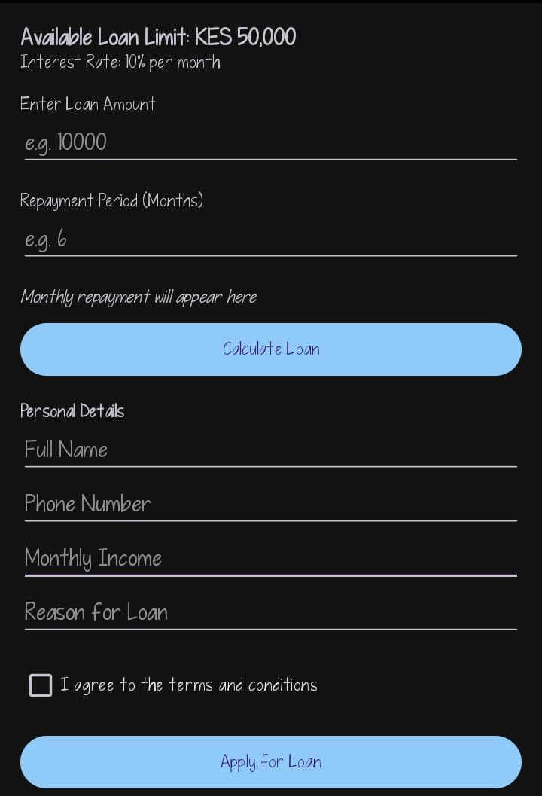
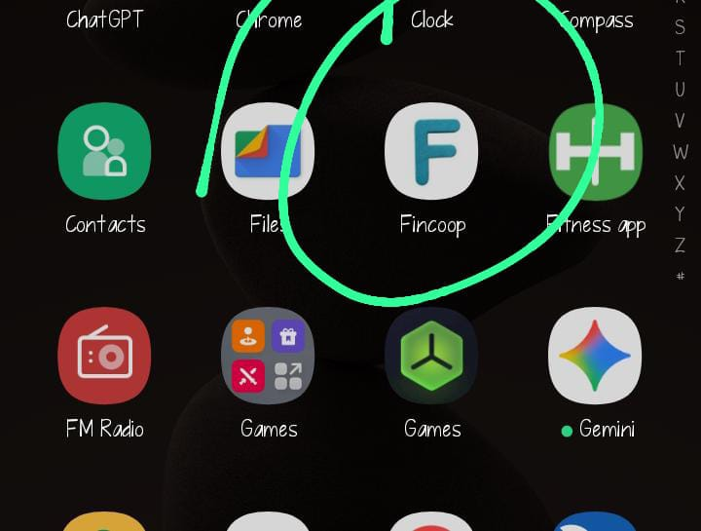

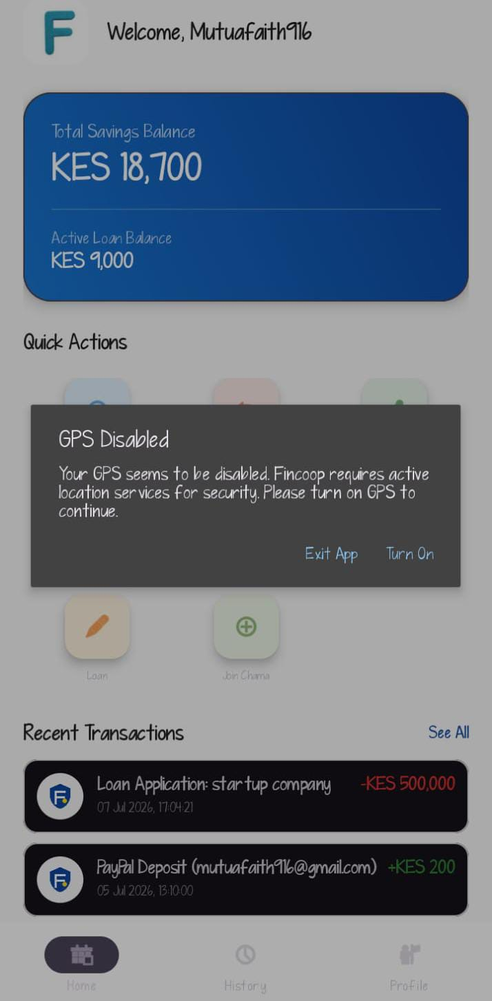
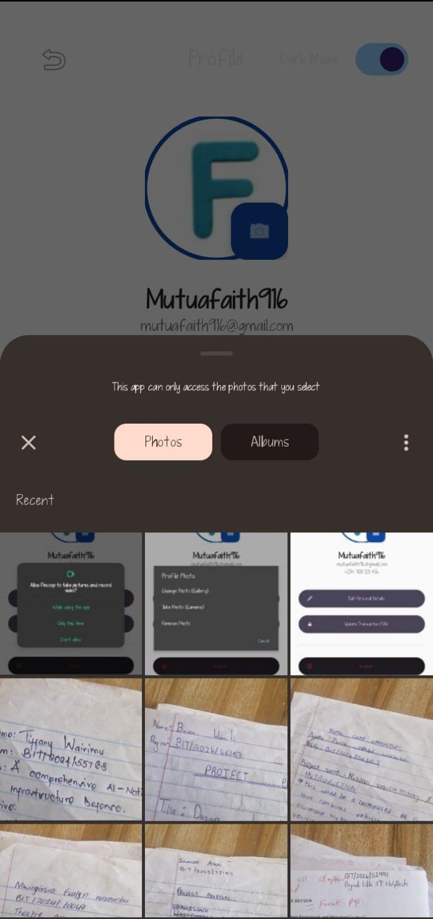
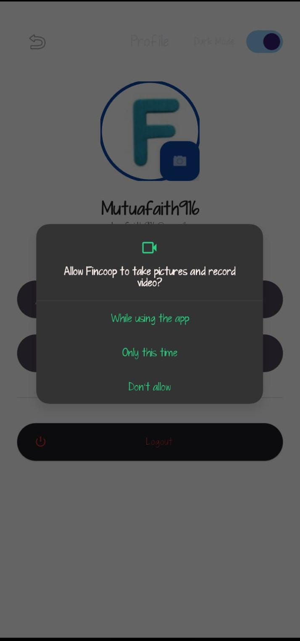
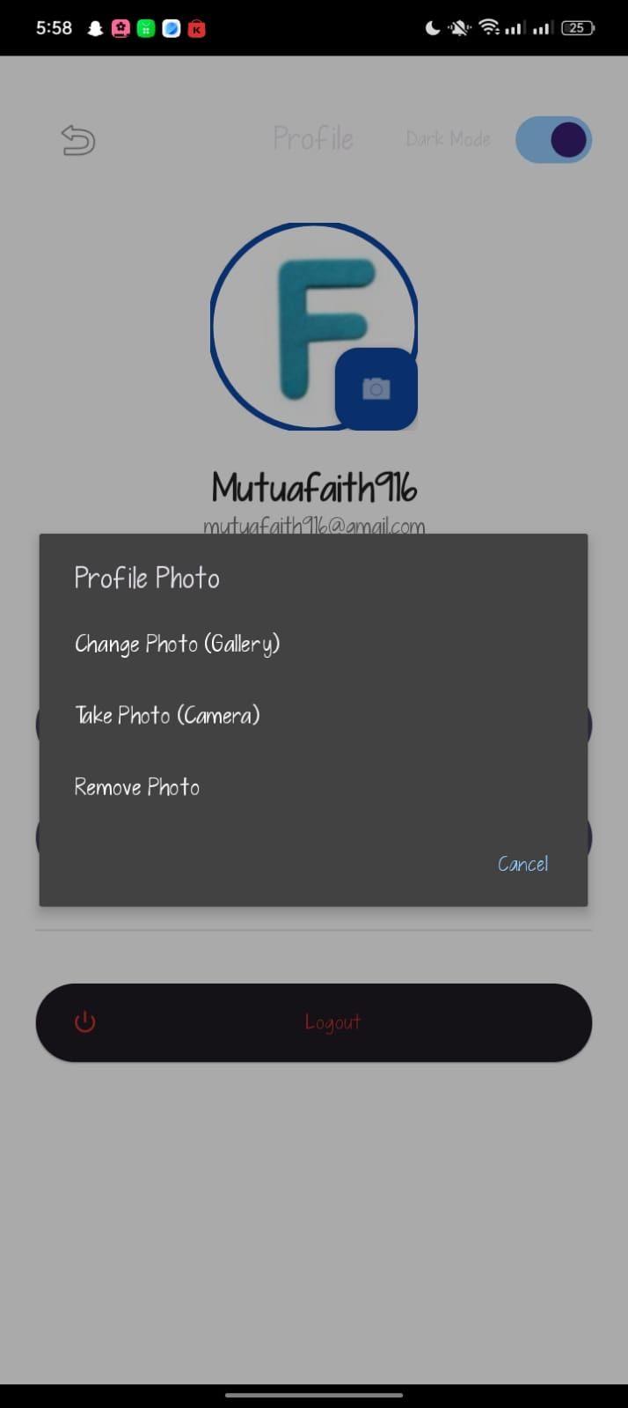
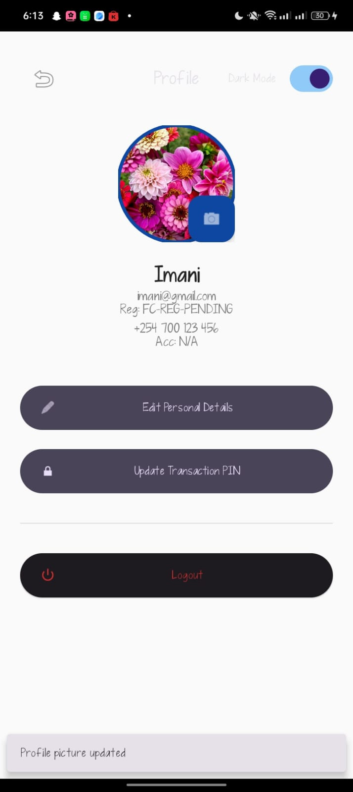
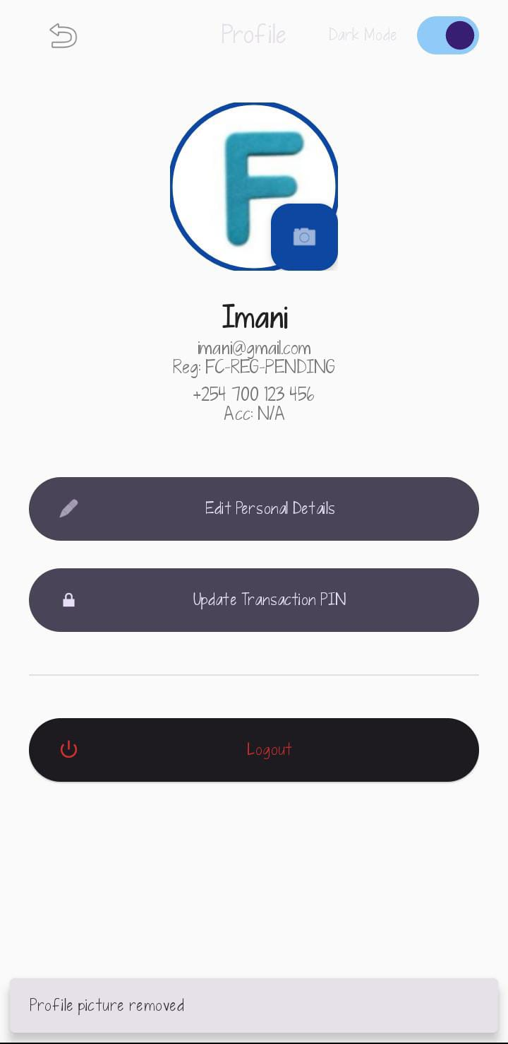
Personal reflection
During Week 10 and 11 ,I integrated all the major features of my FinCoop application, including the login, dashboard, loan application, transaction history, and camera/GPS functions. I tested each feature, fixed errors, improved navigation, and ensured data was stored correctly. This process helped me understand the importance of integrating and testing all application components to create a reliable and user-friendly mobile application . During Week 11, I prepared my FinCoop application for deployment by adding a professional app icon and splash screen, performing final testing, and capturing screenshots of the key features. I also ensured the application was stable, easy to use, and ready for presentation. This experience helped me understand the final stages of mobile app development and the importance of delivering a polished, professional application.

